UNITED STATES

SECURITIES AND EXCHANGE COMMISSION

Washington, D.C. 20549

FORM 6-K

Report of Foreign Private Issuer

Pursuant to Rule 13a-16 or 15d-16

under the Securities Exchange Act of 1934

For the month of November 2018

Commission File Number: 001-34754

China New Borun Corporation

(Translation of Registrant’s name into English)

Bohai Industrial Park

Yangkou Town

Shouguang, Shandong 262715

People’s Republic of China

(Address of principal executive offices)

Indicate by check mark whether the registrant files or will file annual reports under cover of Form 20-F or Form 40-F:

x Form 20-F o Form 40-F

Indicate by check mark if the registrant is submitting the Form 6-K in paper as permitted by Regulation S-T Rule 101(b)(1): o

Indicate by check mark if the registrant is submitting the Form 6-K in paper as permitted by Regulation S-T Rule 101(b)(7): o

SIGNATURE

Pursuant to the requirements of the Securities Exchange Act of 1934, the registrant has duly caused this report to be signed on its behalf by the undersigned, thereunto duly authorized.

China New Borun Corporation

By: | /s/ Jinmiao Wang
Name: | Jinmiao Wang
Title: | Chief Executive Officer

Date: November 30, 2018

 | EXHIBIT INDEX
Exhibit 99.1 | Notice of Annual General Meeting
Exhibit 99.2 | Proxy Statement
Exhibit 99.3 | Form of Proxy for Annual General Meeting
Exhibit 99.4 | Voting Instruction Card for American Depositary Shares
Exhibit 99.5 | Press Release dated November 30, 2018

Exhibit 99.1

CHINA NEW BORUN CORPORATION

NOTICE OF ANNUAL GENERAL MEETING OF SHAREHOLDERS

TO BE HELD ON December 28, 2018

Notice is hereby given that China New Borun Corporation, a Cayman Islands company (the “Company”), will hold its annual general meeting of shareholders at 10:00 a.m., local time, on December 28, 2018 (the “Annual General Meeting”) at the Company's corporate office located at Bohai Industrial Park (Yangkou Town), Shouguang, Shandong 262715, People's Republic of China, to consider and, if thought fit, to pass, the following resolutions:

- As an ordinary resolution, THAT Hengxiu Song be re-elected as a director of the Company, to hold office until the close of the next annual general meeting of shareholders of the Company, or his earlier death, resignation or removal.

- As an ordinary resolution, THAT Jinmiao Wang be re-elected as a director of the Company, to hold office until the close of the next annual general meeting of shareholders of the Company, or his earlier death, resignation or removal.

- As an ordinary resolution, THAT Binbin Jiang be re-elected as a director of the Company, to hold office until the close of the next annual general meeting of shareholders of the Company, or his earlier death, resignation or removal.

- As an ordinary resolution, THAT Xisheng Lu be re-elected as a director of the Company, to hold office until the close of the next annual general meeting of shareholders of the Company, or his earlier death, resignation or removal.

- As an ordinary resolution, THAT Shufeng Jia be elected as a director of the Company, to hold office until the close of the next annual general meeting of shareholders of the Company, or his earlier death, resignation or removal.

- As an ordinary resolution, THAT the appointment of the independent auditor WWC, P.C. Certified Accountants for the fiscal year ending December 31, 2018 be ratified, confirmed, approved and adopted.

- To transact any such other business that may properly come before the meeting.

You can find more information about each of these items, including the nominees for directors, in the attached proxy statement. Only holders of ordinary shares registered in the register of members at the close of business on November 30, 2018, New York time, can vote at the Annual General Meeting or at any adjournment that may take place. If you are a holder of American Depositary Shares, please see the discussion in the attached proxy statement under the heading “Voting by Holders of American Depositary Shares.”

We cordially invite all holders of ordinary shares to attend the Annual General Meeting in person. However, holders of ordinary shares entitled to attend and vote are entitled to appoint a proxy to attend and vote instead of such holders. A proxy need not be a shareholder of the Company. If you are a holder of ordinary shares and whether or not you expect to attend the Annual General Meeting in person, please mark, date, sign and return the enclosed form of proxy as promptly as possible to ensure your representation and the presence of a quorum at the Annual General Meeting. If you send in your form of proxy and then decide to attend the Annual General Meeting to vote your ordinary shares in person, you may still do so. Your proxy is revocable in accordance with the procedures set forth in the proxy statement. The enclosed form of proxy is to be delivered to the attention of Jinmiao Wang, China New Borun Corporation, Bohai Industrial Park (Yangkou Town), Shouguang, Shandong 262715, People's Republic of China, and must arrive no later than the time for holding the Annual General Meeting or any adjournment thereof. This notice of the Annual General Meeting of Shareholders and the attached proxy statement are also available through our website at http://ir.chinanewborun.com.

By Order of the Board of Directors,

/s/ Jinmiao Wang

Jinmiao Wang

Chairman and Chief Executive Officer

November 30, 2018

Exhibit 99.2

CHINA NEW BORUN CORPORATION

PROXY STATEMENT

General

Our board of directors is soliciting proxies for the annual general meeting of shareholders to be held on December 28, 2018 at 10:00 a.m., local time, or at any adjournment or postponement thereof (the “Annual General Meeting”). The Annual General Meeting will be held at our corporate office located at Bohai Industrial Park (Yangkou Town), Shouguang, Shandong 262715, People’s Republic of China.

Record Date, Share Ownership and Quorum

Record holders of ordinary shares as of the close of business on November 30, 2018, New York time, are entitled to vote at the Annual General Meeting. As of November 30, 2018, 25,725,000 of our ordinary shares, par value US$0.001 per share, were issued and outstanding, approximately 12,862,500 of which were represented by American Depositary Shares (“ADSs”). The holders of ordinary shares being not less than an aggregate of one-half of all ordinary shares in issue present in person or by proxy and entitled to vote shall be a quorum for all purposes.

Voting and Solicitation

Holders of ordinary shares outstanding on the record date are entitled to one vote for each ordinary share held. At the Annual General Meeting, every holder of ordinary shares present in person or by proxy may vote the fully paid ordinary shares held by such holder of ordinary shares. A resolution put to the vote of a meeting shall be decided on a show of hands, or on a poll, if a poll is demanded by the Chairman of the Board of Directors, who will act as chairman of the Annual General Meeting, or one or more shareholders present in person or by proxy. The Company expects that the Chairman of the Board of Directors will demand a poll at the Annual General Meeting, in which case, the affirmative vote of a simple majority of the votes of the holders of ordinary shares present in person or represented by proxy and entitled to vote at the Annual General Meeting will be required to elect the five nominees for director and ratify the appointment of the Company’s independent auditor.

The costs of soliciting proxies will be borne by us. Proxies may be solicited by certain of our directors, officers and regular employees, without additional compensation, in person or by telephone or electronic mail. Copies of solicitation materials will be furnished to banks, brokers, fiduciaries and custodians holding in their names our ordinary shares or ADSs beneficially owned by others to forward to those beneficial owners.

Voting by Holders of Ordinary Shares

Holders of ordinary shares whose shares are registered in their own names may vote by attending the Annual General Meeting in person or by completing, dating, signing and returning the enclosed form of proxy to the attention of Jinmiao Wang, China New Borun Corporation, Bohai Industrial Park (Yangkou Town), Shouguang, Shandong 262715, People’s Republic of China. The form of proxy must arrive no later than the time for holding the Annual General Meeting or any adjournment thereof.

When proxies are properly completed, dated, signed and returned by holders of ordinary shares, the ordinary shares they represent, unless the proxies are revoked, will be voted at the Annual General Meeting in accordance with the instructions of the shareholder. If no specific instructions are given by such holders, the ordinary shares will be voted “FOR” each proposal and in the proxy holder’s discretion as to other matters that may properly come before the Annual General Meeting. Abstentions and broker non-votes will be counted as present for purposes of determining whether a quorum is present. Abstentions will have the same effect as a vote against the election of directors and the ratification of the appointment of the independent auditor. Broker non-votes will have no effect on the outcome of the vote for the election of directors, but will have the same effect as a vote against the appointment of the independent auditor. Note that if your ordinary shares are held of record by a broker or nominee, such broker or nominee will not have authority to vote your ordinary shares in the election of directors unless you provide instructions to him or her regarding how you would like your shares to be voted.

Please refer to this proxy statement and our annual report for 2017 for information related to the proposals. China New Borun Corporation’s 2017 Annual report on Form 20-F, including its audited financial statements, for the fiscal year ended December 31, 2017, has been posted on the Investor Relations section of the Company’s website at http://www.chinanewborun.com, and can also be accessed from the SEC’s website at http://www.sec.gov.

Voting by Holders of American Depositary Shares

The Bank of New York Mellon, as depositary of the ADSs, has advised us that it intends to mail to all record owners of ADSs this proxy statement, the accompanying notice of Annual General Meeting and a voting instruction card for record owners of ADSs. Upon the written request of an owner of record of ADSs by such owner’s delivery of a properly completed, dated and signed voting instruction card to The Bank of New York Mellon prior to 5:00 pm, New York time on December 21, 2018, The Bank of New York Mellon will endeavor, in so far as practicable, to vote or cause to be voted the amount of ordinary shares or other deposited securities represented by such ADSs, evidenced by American Depositary Receipts related to those ADSs, in accordance with the instructions set forth in such request. The Bank of New York Mellon has advised us that it will not vote or attempt to exercise the right to vote other than in accordance with those instructions. If your ADSs are held of record by a broker or nominee, such broker or nominee will not have authority to deliver voting instructions to The Bank of New York Mellon with respect to the election of directors unless you provide instructions to your broker or nominee regarding how you would like the voting instructions to be completed. As the holder of record for all the ordinary shares represented by all of our ADSs, only The Bank of New York Mellon may vote those ordinary shares at the Annual General Meeting.

The Bank of New York Mellon and its agents have advised us that they are not responsible if they fail to carry out your voting instructions or for the manner in which they carry out your voting instructions. This means that if the ordinary shares underlying your ADSs are not able to be voted at the annual general meeting, there may be nothing you can do.

If the enclosed voting instruction card is signed but is missing voting instructions, The Bank of New York Mellon will give discretionary proxy to a person designated by the Company; if the enclosed voting instruction card is improperly completed, The Bank of New York Mellon will not vote the ordinary shares underlying the ADSs to which such voting instruction card relates.

Revocability of Proxies

Any proxy given pursuant to this solicitation may be revoked by the person giving it at any time before its use by delivering a written notice of revocation or a duly executed proxy bearing a later date or, if you hold ordinary shares, by attending the meeting and voting in person. A written notice of revocation must be delivered to the attention of China New Borun Corporation, if you hold our ordinary shares, or to The Bank of New York Mellon if you hold ADSs representing our ordinary shares.

PROPOSALS 1, 2, 3, 4 AND 5

ELECTION OF DIRECTORS

Background

Our Board of Directors currently consists of five members. One of the purposes of the Annual General Meeting is to re-elect four directors and to elect one director to hold office until the next annual general meeting of shareholders.

The Governance and Nominating Committee has nominated our current directors, Jinmiao Wang, Hengxiu Song, Binbin Jiang and Xisheng Lu for re-election and Shufeng Jia for election at the Annual General Meeting.

We are not required by the law of the Cayman Islands, our Memorandum and Articles of Association or the rules of the New York Stock Exchange to hold an annual election for our directors, as our Memorandum and Articles of Association provide for indefinite terms for members of our Board of Directors. However, we view an annual election for directors as key to effecting good corporate governance.

Vote Required and Board Recommendation

If a quorum is present and upon demand of a poll, the affirmative vote of a simple majority of the votes of the holders of ordinary shares present in person or represented by proxy and entitled to vote at the Annual General Meeting will be required to elect the five nominees for director.

THE BOARD OF DIRECTORS RECOMMENDS A VOTE “FOR” EACH OF

PROPOSALS 1, 2, 3, 4 AND 5,

THE ELECTION OF EACH OF THE NOMINEES NAMED ABOVE

Information regarding Director Nominees

Ordinary shares represented by executed proxies will be voted, if authority to do so is not withheld, for the election of the nominees named below. The Board of Directors has no reason to believe that any of the nominees named below will be unable or unwilling to serve as a director if elected. In the event that any nominee should be unavailable for election as a result of an unexpected occurrence, such ordinary shares will be voted for the election of such substitute nominee as management may propose.

The names of the nominees, their respective ages as of November 30, 2018, the principal positions currently held by them and their biographies are as follows:

Name |  | Age |  | Position
Hengxiu Song |  | 47 |  | Chief Operations Officer, General Manager of Shandong Borun Industrial Co. Ltd and Director
Jinmiao Wang |  | 48 |  | Chief Executive Officer and Chairman of the Board
Binbin Jiang |  | 44 |  | Independent Director
Xisheng Lu |  | 68 |  | Independent Director
Shufeng Jia |  | 40 |  | Independent Director

Hengxiu Song has served as our chief operations officer since 2010 and served as the general manager of Shandong Borun Industrial Co. Ltd., our wholly-owned subsidiary, since 2011. He has also served as the director of administration of Shandong Borun Industrial Co. Ltd. since April 2005. From April 2010 to November 2010 and from June 2011 to present, Mr. Song has served as director. From February 2002 to March 2005, Mr. Song served as the marketing and purchasing director of Shandong Borun Salt Industrial Co. Ltd., the predecessor company of Shandong Borun Industrial Co. Ltd. Mr. Song obtained a bachelor’s degree in Economics and Management from the Capital University of Economics and Business.

Jinmiao Wang has served as our Chief Executive Officer and Chairman of the Board of Directors since 2010. Mr. Wang also serves as the chairman of Shandong Borun Industrial Co. Ltd and has served in such capacity since July 2008. Prior to that, Mr. Wang served as the chairman and general manager of Shandong Borun Industrial Co. Ltd. from March 2006 to July 2008. From June 2004 to March 2006, Mr. Wang served as the chairman and general manager of Shandong Borun Salt Industrial Co. Ltd., the predecessor company of Shandong Borun Industrial Co. Ltd. From December 2000 to June 2004, Mr. Wang served as the chairman and general manager of Shouguang Haihong Salt-Making Co. Ltd. in the city of Shouguang in Shandong Province. Mr. Wang has been honored as a private entrepreneur in Shandong Province, having made significant contributions to his local economy in China.

Binbin Jiang has served as our independent director since June 2010. Since July 1997, he has served as the general secretary of Shandong Alcohol Industry Association, a member of the Technology Committee of the China Alcoholic Drinks Industry Association, Alcohol Branch, the vice general secretary of Shandong White Spirits Industry Association, the vice general secretary of Shandong Beer Industry Association, and the vice president of Shandong Food Industry Limited. He obtained a bachelor’s degree in Fermentation from Food Engineering School of Shandong Institute of Light Industry.

Xisheng Lu has served as our independent director since January 2013. Since 1991, he has served as Chairman & Factory Director of Jin Long Distillery Factory in Qionglai City, Sichuan Province, China. From 1976 to 1990, he served as Factory Director of the First Liquor Making Branch Factory of Qionglai Sugar & Liquor Factory, the predecessor of Jin Long Distillery Factory. In 2002, Mr. Lu was elected as a standing director of the Alcoholic Drinks (bai jiu) Association of Sichuan Province and an editor of the Sichuan Province Alcoholic Drinks (bai jiu) Magazine. In 2007, Mr. Lu received the certificate of National Senior Alcoholic Drinks (bai jiu) maker. Mr. Lu is a Senior Engineer for the making of bai jiu. He has nearly 40 years’ experience in the bai jiu industry

Shufeng Jia has served as Chief Financial Officer of Landian Biological Technologies Corporation Limited in Shandong since January 2013. From November 2001 to December 2012, she served as Finance Manager and Finance Controller of Shandong Molong Petroleum Machinery Co., Ltd. Mrs. Jia obtained a bachelor’s degree in Qingdao University of Science & Technology.

PROPOSAL 6

RATIFICATION OF APPOINTMENT OF THE INDEPENDENT AUDITOR

Background

We are asking holders of ordinary shares to ratify the Audit Committee’s appointment of WWC, P.C. Certified Accountants ("WWC") as the Company’s independent auditor for the fiscal year ending December 31, 2018. WWC is a registered public accounting firm with the Public Company Accounting Oversight Board (“PCAOB”), as required by the Sarbanes-Oxley Act of 2002 and the rules of the PCAOB. In the event the holders of ordinary shares fail to ratify the appointment, the Audit Committee will reconsider this appointment. Even if the appointment is ratified, the Audit Committee, in its discretion, may direct the appointment of different independent auditors at any time during the year if the Audit Committee determines that such a change would be in the Company’s and its shareholders’ best interests.

Vote Required and Board Recommendation

If a quorum is present and upon demand of a poll, the affirmative vote of a simple majority of the votes of the holders of ordinary shares present in person or represented by proxy and entitled to vote at the Annual General Meeting will be required to ratify the appointment of WWC as the Company’s independent auditor for the fiscal year ending December 31, 2018.

THE BOARD OF DIRECTORS RECOMMENDS A VOTE “FOR” PROPOSAL 6 , THAT THE APPOINTMENT OF BDO AS THE COMPANY’S INDEPENDENT AUDITOR FOR THE FISCAL YEAR ENDING DECEMBER 31, 2017 BE RATIFIED, CONFIRMED, APPROVED AND ADOPTED.

OTHER MATTERS

We know of no other matters to be submitted to the Annual General Meeting. If any other matters properly come before the Annual General Meeting, it is the intention of the persons named in the enclosed form of proxy to vote the shares they represent as the board of directors may recommend.

By Order of the Board of Directors,

/s/ Jinmiao Wang

Jinmiao Wang

Chairman and Chief Executive Officer

November 30, 2018

Exhibit 99.3

CHINA NEW BORUN CORPORATION

(incorporated in the Cayman Islands with limited liability)

FORM OF PROXY FOR THE ANNUAL GENERAL MEETING

to be held on December 28, 2018

(or any adjourned or postponed meeting thereof)

I/we, the undersigned acknowledges receipt of the Notice of Annual General Meeting of Shareholders and Proxy Statement and, being the registered holder of 12,862,500 ordinary shares¹, par value US$0.001 per share, of China New Borun Corporation (the “Company”), hereby appoint the Chairman of the Annual
General Meeting² or (Name) |  |  | of
(Address) |  | (or failing which, the Chairman of the Annual General Meeting) as

my/our proxy to attend and act for me/us at the Annual General Meeting² (or at any adjourned or postponed meeting thereof) of the Company to be held at 10:00 a.m., local time, on December 28, 2018 at China New Borun Corporation, Bohai Industrial Park (Yangkou Town), Shouguang, Shandong 262715, People's Republic of China.

My/our proxy is instructed to vote on the resolutions in respect of the matters specified in the Notice of the Annual General Meeting as indicated below:

- Please insert the number of shares registered in your name(s) to which this proxy relates. If no number is inserted, this form of proxy will be deemed to relate to all the shares in the Company registered in your name(s).

- If any proxy other than the Chairman of the Annual General Meeting is preferred, strike out the words “the Chairman of the Annual General Meeting or” and insert the name and address of the proxy desired in the space provided. A proxy need not be a shareholder. If you are the holder of two or more ordinary shares, you may appoint more than one proxy to represent you and vote on your behalf at the Annual General Meeting. Any alteration made to this form of proxy must be initialed by the person(s) who sign(s) it.

For Against Abstain

Proposal 1: As an ordinary resolution, THAT Hengxiu Song be re-elected as a director of the Company, to hold office until the close of the next annual general meeting of shareholders of the Company, or his earlier death, resignation or removal.

Proposal 2: As an ordinary resolution, THAT Jinmiao Wang be re-elected as a director of the Company, to hold office until the close of the next annual general meeting of shareholders of the Company, or his earlier death, resignation or removal.

Proposal 3: As an ordinary resolution, THAT Binbin Jiang be re-elected as a director of the Company, to hold office until the close of the next annual general meeting of shareholders of the Company, or his earlier death, resignation or removal.

Proposal 4: As an ordinary resolution, THAT Xisheng Lu be re-elected as a director of the Company, to hold office until the close of the next annual general meeting of shareholders of the Company, or his earlier death, resignation or removal.

Proposal 5: As an ordinary resolution, THAT Shufeng Jia be elected as a director of the Company, to hold office until the close of the next annual general meeting of shareholders of the Company, or his earlier death, resignation or removal.

Proposal 6: As an ordinary resolution, THAT the appointment of the independent auditor WWC, P.C. Certified Accountants for the fiscal year ending December 31, 2018 be ratified, confirmed, approved and adopted.

Dated_________________, 2018

Signature(s) ___________________________________

Name of Signatory ______________________________

Notes:

- Only the holders of record of the ordinary shares of the Company at the close of business on November 30, 2018, New York time, should use this form of proxy.

- Please indicate your voting preference by ticking, or inserting in the number of shares to be voted for or against or to abstain, the boxes above in respect of each resolution. If NO instruction is given, your proxy will vote or abstain from voting at his/her discretion. If any other matter properly comes before the Annual General Meeting, or any adjournment or postponement thereof, which may properly be acted upon, unless otherwise indicated, your proxy will vote or abstain from voting at his/her discretion.

- Any alteration made to this form of proxy must be initialed by the person(s) who sign(s) it.

- This form of proxy must be signed by you or your attorney duly authorized in writing or, in the case of a corporation, must be either under seal or executed under the hand of an officer or attorney duly authorized to sign the same. In the case of joint holders, all holders must sign.

- This form of proxy and any authority under which it is executed (or a notarized and/or duly certified copy of such authority) must be returned to the attention of Jinmiao Wang, China New Borun Corporation, Bohai Industrial Park (Yangkou Town), Shouguang, Shandong 262715, People's Republic of China no later than the time for holding the Annual General Meeting or any adjournment thereof.

- Completion and return of the form of proxy will not prevent you from attending and voting in person at the Annual General Meeting.

Exhibit 99.4
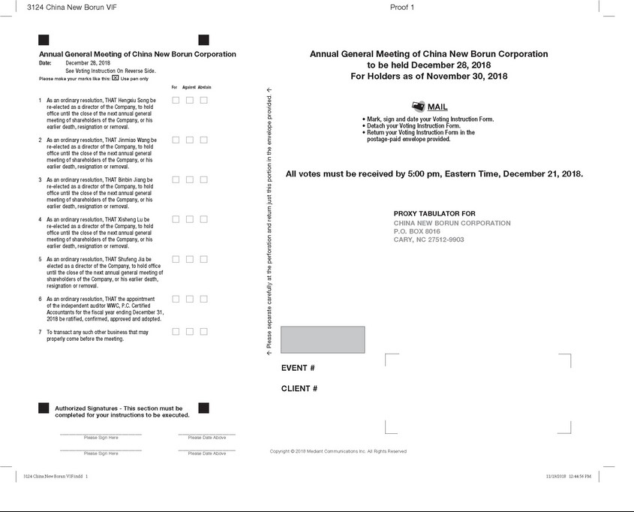

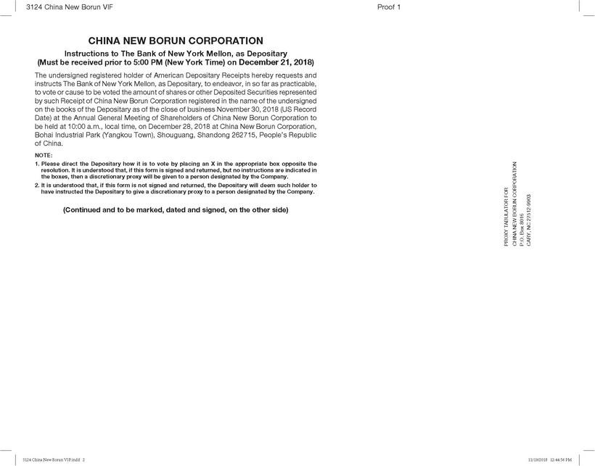

Exhibit 99.5

China New Borun to Hold Annual General Meeting on December 28, 2018

BEIJING, China, November 30, 2018 – China New Borun Corporation (NYSE: BORN; “Borun” or the “Company”), a leading producer and distributor of corn-based edible alcohol in China, announces today that it will hold its annual general meeting of shareholders at 10:00 a.m. Beijing/Hong Kong time on December 28, 2018 at the Company’s corporate office located at Bohai Industrial Park (Yangkou Town), Shouguang, Shandong province, People’s Republic of China.

Record holders of ordinary shares as of the close of business on November 30, 2018, New York time, are entitled to notice of, and to vote at, the annual general meeting or any adjournment or postponement thereof. Holders of the Company’s American depositary shares (“ADSs”) who wish to exercise their voting rights for the underlying ordinary shares must act through the depositary of the Company’s ADS program, The Bank of New York Mellon.

The purpose of the annual general meeting will be to re-elect Mr. Hengxiu Song, Mr. Jinmiao Wang, Mr. Binbin Jiang, and Mr. Xisheng Lu and elect Mrs. Shufeng Jia to the Company’s board of directors and ratify the appointment of its auditors, WWC, P.C. Certified Accountants for the fiscal year ending December 31, 2018.

The notice of the annual general meeting, which sets forth the resolutions to be submitted to shareholder approval at the meeting, is available on the Investor Relations section of the Company’s website at http://ir.chinanewborun.com. A copy of the Company’s proxy statement has been filed with the U.S. Securities and Exchange Commission (the “SEC”).

Additionally, a copy of China New Borun Corporation’s 2017 Annual report on Form 20-F, including its audited financial statements, for the fiscal year ended December 31, 2017, has been posted on the Investor Relations section of the Company’s website for download at the following link: http://ir.chinanewborun.com/phoenix.zhtml?c=236223&p=irol-sec, and can be also accessed on the SEC’s website at http://www.sec.gov.

About China New Borun Corporation

China New Borun Corporation (NYSE: BORN) is a leading producer and distributor of corn-based edible alcohol sold as an ingredient to producers of baijiu, a popular grain-based alcoholic beverage in China. The Company also produces DDGS Feed, liquid carbon dioxide and crude corn oil as by-products of edible alcohol production, and chlorinated polyethylene (CPE) that are widely used in chemical industries. China New Borun is based in Shouguang, Shandong Province. Additional information about the company can be found at http://www.chinanewborun.com and in documents filed with the U.S. Securities and Exchange Commission, which are available on the SEC’s website at http://www.sec.gov.

Contact Information

Chief Executive Officer

Jinmiao Wang

Phone: +86-536-545 1199 (China)

Email: Jinmiao.wang@chinanewborun.com

